This tutorial is deprecated. Please read “install_windows.txt” and follow instructions to setup your env with the great scoop tool.
Installing Windows tools for pdf2pdfocr
Install software dependencies according with your architecture.
Script is tested with these versions (32/64 bits).
URL | Installation files
http://gnuwin32.sourceforge.net/packages/file.htm | file-5.03-setup.exe (only 32 bit available – it will work on 64 bit architecture)
http://ghostscript.com/download/gsdnld.html | gs923w32.exe  gs923w64.exe
http://www.imagemagick.org/script/download.php | ImageMagick-7.0.8-10-Q16-x64-dll.exe  ImageMagick-7.0.8-10-Q16-x86-dll.exe
https://www.pdflabs.com/tools/pdftk-server/ | pdftk_server-2.02-win-setup.exe (only 32 bit available – it will work on 64 bit architecture)
http://blog.alivate.com.au/poppler-windows/ | poppler-0.67.0_x86.7z (only 32 bit available – it will work on 64 bit architecture)
https://github.com/UB-Mannheim/tesseract/wiki | tesseract-ocr-setup-3.05.02-20180621.exe (only 32 bit available – it will work on 64 bit architecture)
https://www.python.org/downloads/windows/ | python-3.6.6-amd64.exe  python-3.6.6.exe
Caveats, please read carefully:
- Add tools to system path when software installation offer this option.
- You have to manually add to path: tesseract, file, ghostscript (bin & lib) and poppler. In my installation…
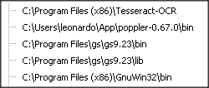
- ImageMagick must be installed with “legacy utilities” and added to system path.
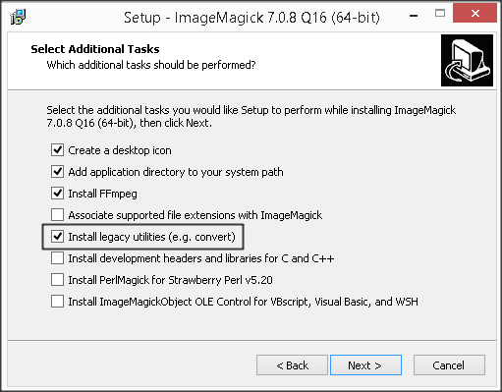
- Tesseract must be installed with all languages you want to OCR (default is English only). Portuguese example:
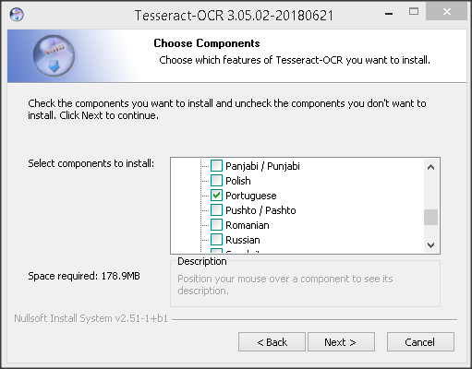
- Please also check if environment variable “TESSDATA_PREFIX” is pointing to correct folder.
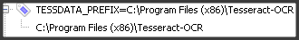
- After install python 3.6.6 (don’t forget to add to system path during installation), open command prompt and run:
  - “easy_install -U pip”;
  - “pip install reportlab”
  - “pip install https://github.com/mstamy2/PyPDF2/archive/master.zip”
    - (pypdf2 must be installed from sources).

Download PDF2PDFOCR from Github:
https://github.com/LeoFCardoso/pdf2pdfocr/archive/master.zip
Extract all files to “%USERPROFILE%\pdf2pdfocr”. Please be careful with subfolders. You must got something like this:
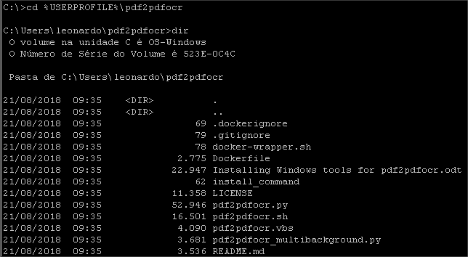

Move “%USERPROFILE%\pdf2pdfocr\pdf2pdfocr.vbs” to “shell:sendto” folder (use windows explorer)

Select one or more supported files and choose “Send to/pdf2pdfocr.vbs”.

